AIM: Plot the membership functions in fuzzy logic.

SOURCE CODE:

fis = readfis('tipper');

plotmf(fis,'input',1)

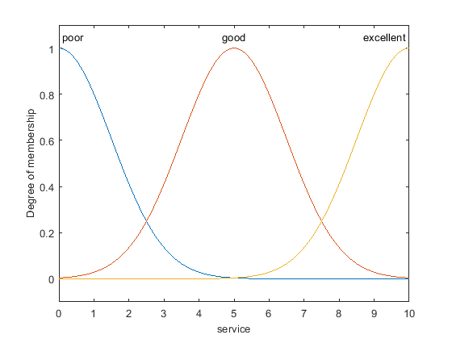

fis = readfis('tipper');

plotmf(fis,'output',1,101)

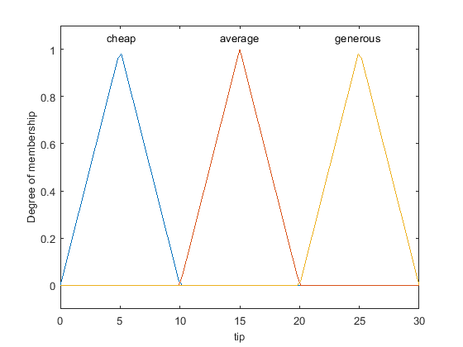

fis = readfis('tipper');

[xOut,yOut] = plotmf(fis,'input',2);

plot(xOut(:,2),yOut(:,2))

xlabel('food')

ylabel('delicious membership')

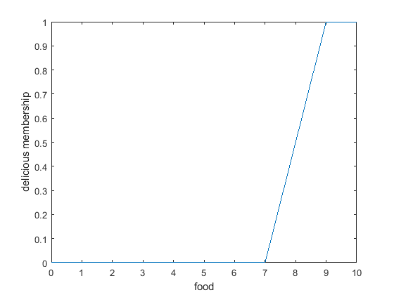

fis = mamfistype2('NumInputs',3,'NumOutputs',1);

plotmf(fis,'input',1)

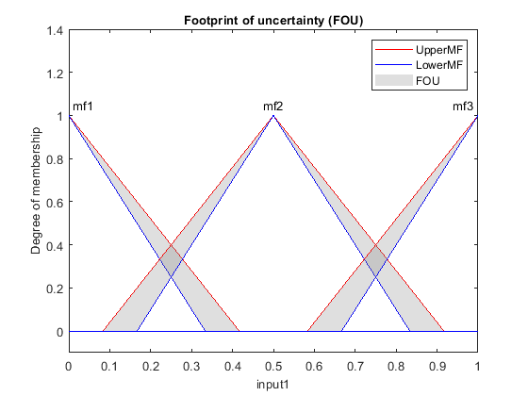

[xOut,umfOut,lmfOut] = plotmf(fis,'input',1);

plot(xOut(:,2),umfOut(:,2),'r',xOut(:,2),lmfOut(:,2),'b')

xlabel('input1')

ylabel('delicious membership')

